United States Office of Personnel Management

CFC Text-to-Donate

User Guide

Text to Donate
In addition to the online pledging system, users can utilize the Text-To-Donate Feature
- Text DONATE to 978-487-5678
  - Link #1 will take the user through the One-Time Credit Card Text-To-Donate workflow
  - Link #2 will take the user to the mobile version of the full CFC Website to:
    - Set up a pledge account
    - Log into the current Pledge Account
    - Set up recurring ACH/CC or Payroll Deductions
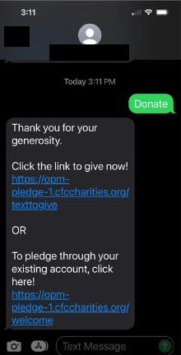
Link #1 Homepage Link #2 Homepage
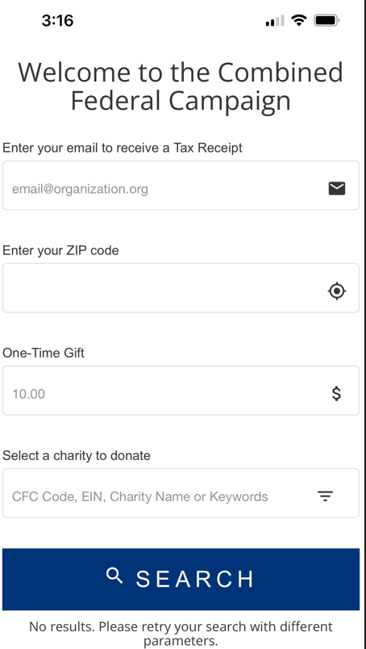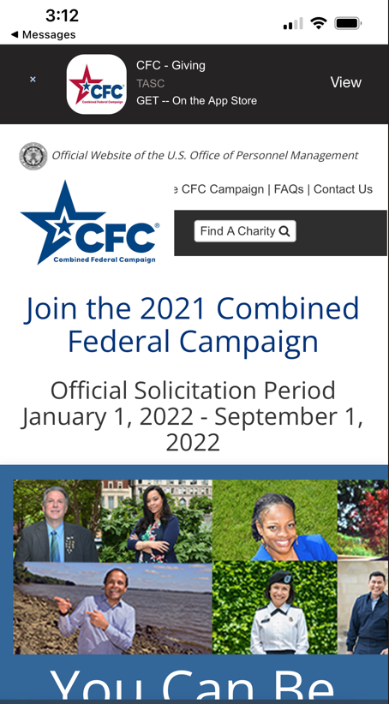

- Select Link #1 to proceed through the Text-To-Donate Prompts
(All fields will be validated upon submission)
  - Enter Email for a Tax Receipt
  - Enter Zip Code
  - Enter Amount Pledged (0.00 format)
  - Enter CFC Code, Charity Name, or Keyword for search
    - Use the filtering option to decrease the number of search results returned
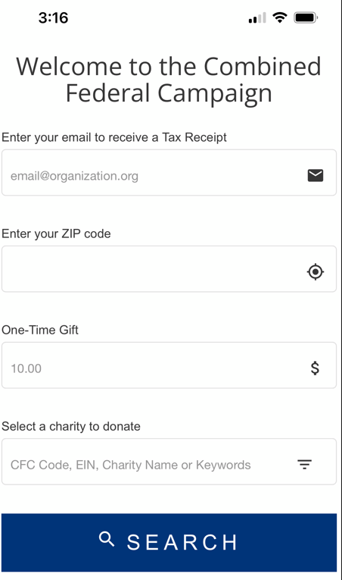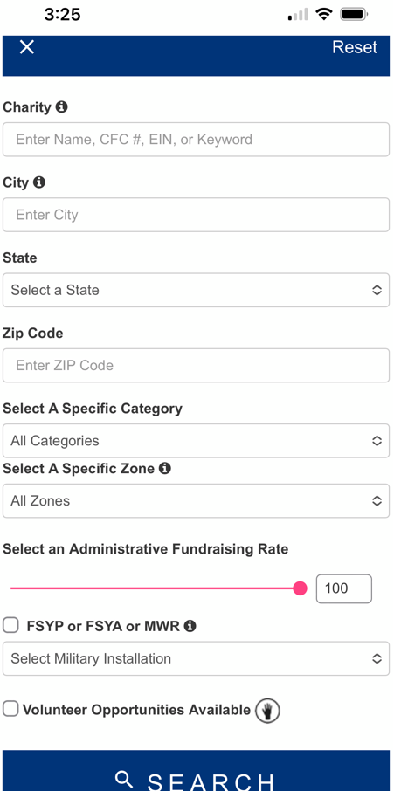
Search Filter

- Once the charity is located, choose the SELECT option at the bottom of the screen
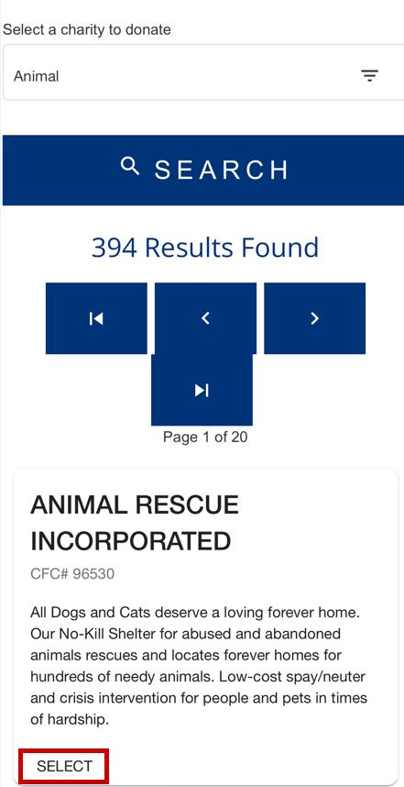

- Once all pledge and charity details are entered, select CONTINUE to proceed to the payment screen

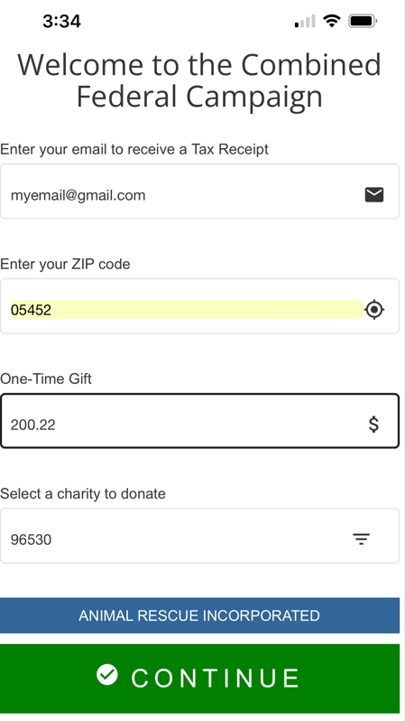

- Payment options are PayPal or Credit Card
  - Once a payment option is selected and completed, select SUBMIT
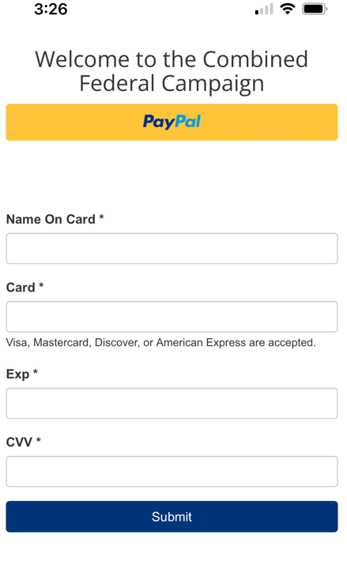
- When payment is processed, a confirmation screen will appear
